Template for Preparing an Article

Author One1, Author Two2, Author Three3,*

1Department Name, Organization Name, City, Country

2Department Name, Organization Name, City, Country

3Department Name, Organization Name, City, Country

*Corresponding author: author3@email

**Abstract** This document gives formatting instructions for authors preparing papers for publication in this journal. Authors are encouraged to prepare manuscripts directly using this template. This template demonstrates format requirements for the Journal.

**Keywords:** format, word template, style, insert, template

1. Introduction

To use this template, you will need to (1) apply the embedded styles to each paragraph-level item in your manuscript or (2) use the specifications shown in Table 1 to format your manuscript, with this template as a visual guide. Information about paper submission is available from the Journal website.

Table 1. Font Sizes for Papers

|  |  |  |  |
| --- | --- | --- | --- |
| Font Size | Appearance (in Time New Roman) | | |
| Regular | Bold | Italic |
| 1 | content | content | content |
| 2 | content | content | content |
| 3 | content | content | content |
| 4 | content | content | content |
| 5 | content | content | content |
| 6 | content | content | content |

2. Ease of Use

An easy way to comply with the journal paper formatting requirements is to use this document as a template and simply type your text into it.

The template is used to format your paper and style the text. All margins, column widths, line spaces, and text fonts are prescribed; please do not alter them. Your paper is one part of the entire proceedings, not an independent document. Please do not revise any of the current designations.

2.1. Page Layout

Your paper must use a page size corresponding to A4 which is 210mm wide and 297mm long. The margins are set as follows: top= 15 mm, bottom= 15 mm, right=17.5 mm, left = 20 mm. Your paper must be in two column format with a space of 1.93 characters between columns.

2.1.1. Front Matter

The title should be formatted in an inverted pyramid style. Use numerical superscript callouts as shown in this template to link authors with their affiliations. Corresponding author should be denoted with an asterisk as shown. Email address is compulsory for the corresponding author.

2.1.2. Text Font

The entire document should be in times New Roman font size 10. Paper title must be centered, bold, regular font size 20 and all with upper case. Author names must be centered, bold, regular font size 10. Author affiliation must be regular font size 9. Email address must be centered, italic, font size 9. Recommended font sizes are shown in Table 1. No more than 3 levels of headings should be used. Level 1 heading must be left-justified, bold, regular font size 14 and numbered using Arabic numerals. Level 2 headings must be left-justified, bold, regular font size 12 and numbered as sub-heading (i.e., 1.1). Level 3 heading must be left-justified, bold, italic font size 10 and numbered as sub-subheading (i.e., 1.1.1) and the first letter of each word capitalized.

2.1.3. Equations

Display equations should be broken and aligned for two-column display unless spanning across two columns is essential. Equations should be centered with equation numbers set flush right. If using Math Type, use the Format Equations feature to format all equations as Century + Symbol 10.

 (1)

2.1.4. Tables

Styles for table title, table head, and table text are provided. Tables should be set in one column wherever possible and be placed near their first mention in the body. Tables and figures do not need to be placed on separate pages at the back of the manuscript.

2.1.5. Figures

As with tables and equations, figures should be set in one column if possible unless two-column display is essential. The resolution of graphics and image should be adequate to reveal the important detail in the figure.

2.1.6. Figure Captions

Figure captions should be below the figures. Figures must be numbered using Arabic numerals. Figure captions must be in 8 pt Regular font. Captions of a single line (e.g., Figure 2) must be centered whereas multi-line captions must be justified (e.g., Figure 1). Captions with figure numbers must be placed after their associated figures, as shown in Figure 1.

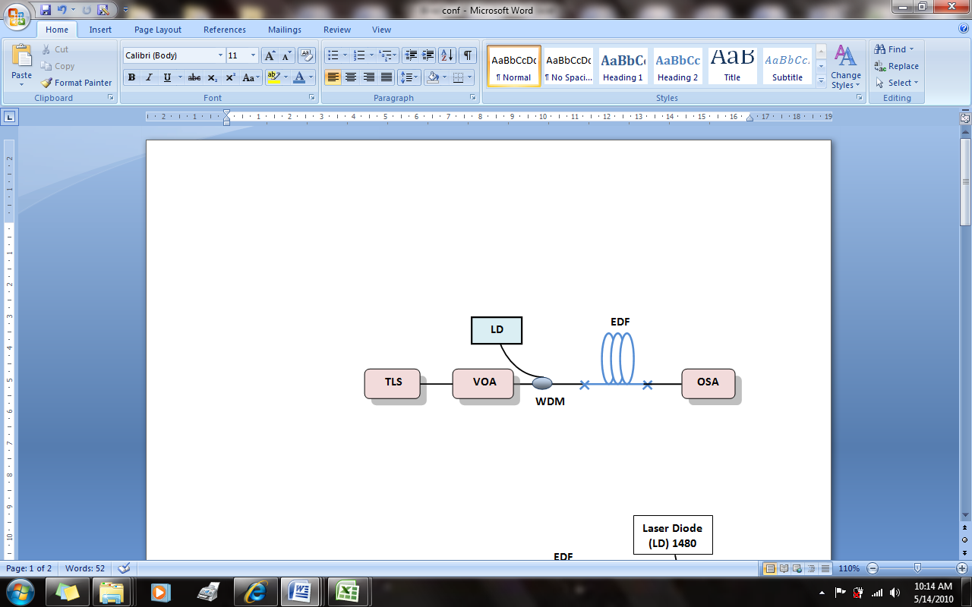**Figure 1.** (Color online) Forward single pass experimental set-up for evaluating EDFA performance



**Figure 2**. Diagram example

2.1.7. Table Captions

Table heads should appear above the tables. Tables must be numbered using Arabic numerals. Table captions must be centered and in 8 pt Regular font. Every word in a table caption must be capitalized. Captions with table numbers must be placed before their associated tables, as shown in Table 1.

3. References Formats

The heading of the References section must not be numbered. All reference items must be in 8 pt font. Number the reference items consecutively in square brackets (e.g. [1]). When referring to a reference item, please simply use the reference number, as in [2]. Do not use “Ref. [3]” or “Reference [3]” except at the beginning of a sentence, e.g., “Reference [3] shows …”. Multiple references are each numbered with separate brackets (e.g. [1-3]).

The different sources documented in the References should follow accurately their corresponding formats in APA Style (7th edition). Below are the formats of most common sources.

Books

Lastname, F. M. (Year). *Title of book in sentence case: Subtitle of book if any*. Publisher.

Print journal article

Lastname, F. M. (Year). Research title in sentence case: Subtitle of research article if any. *Name of Journal in Title Case, volume number* (issue number), page-range.

Online journal article

Lastname, F. M. (Year). Research title in sentence case: Subtitle of research article if any. *Name of Journal in Title Case, volume number* (issue number), page-range. <https://doi.org/xx.xxx/xxxx>

Conference proceeding

Lastname, F. M. (Year). Research title in sentence case: Subtitle of research article if any. *Name of Conference Proceedings Journal in Title Case, volume number* (issue number), page-range. <https://doi.org/xx.xxx/xxxx>

E-book

Lastname, F. M. (Year). *Title of e-book in sentence case: Subtitle of e-book if any*. Publisher. URL

Online article

Lastname, F. M. (Year, Month Date*). Title of online article in sentence case: Subtitle of article if any*. Site name. URL

Acknowledgements

The heading of the Acknowledgment section and the References section must not be numbered.

References

1. Creswell, J. W., & Creswell, J. D. (2018). *Research design: Qualitative, quantitative, and mixed methods approaches* (5th ed.). SAGE Publications.
2. Gresty, K., Pan, W., Heffernan, T., & Edwards-Jones, A. (2013). Research-informed teaching from a risk perspective. *Teaching in Higher Education*, *18*(5), 570-585. <https://doi.org/10.1080/13562517.2013.795937>
3. Kirschner, P., & Surma T. (2020, September 14). *Evidence-informed pedagogy*. Impact. <https://impact.chartered.college/article/evidence-informed-pedagogy/>